**LOGIN PAGE**

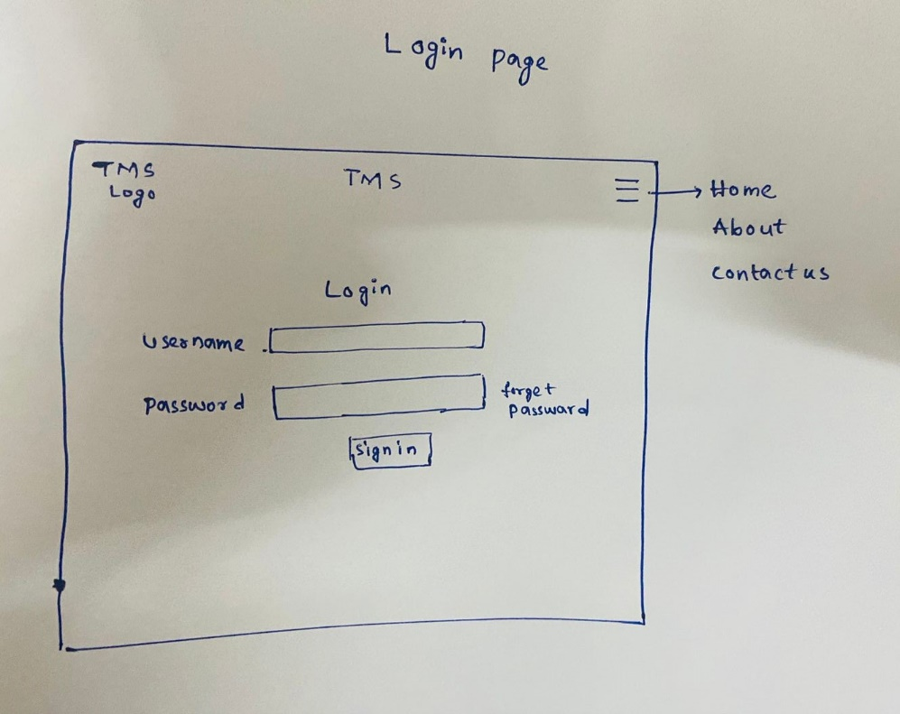

**ADMIN**

**LIST OF USERS**

**ADD USER**

**RTO**

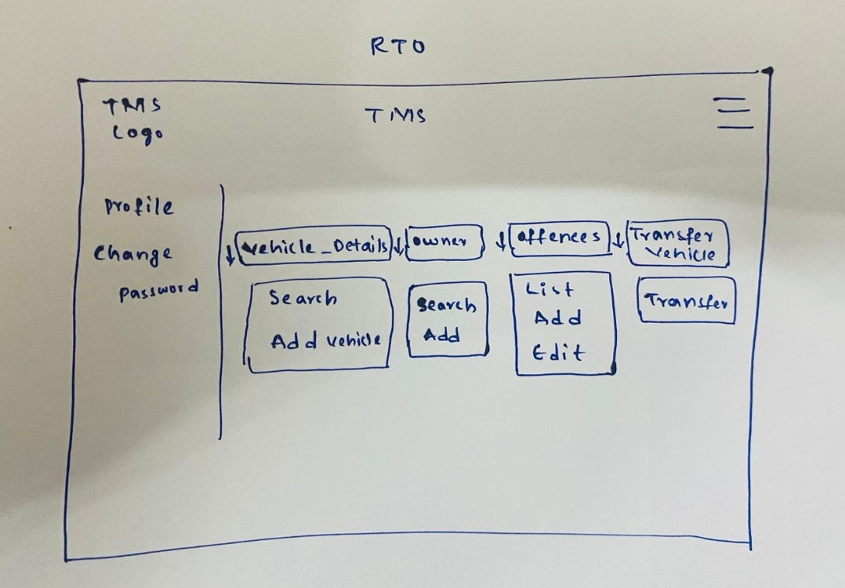

**ADD OWNER**

**ADD VEHICLE**

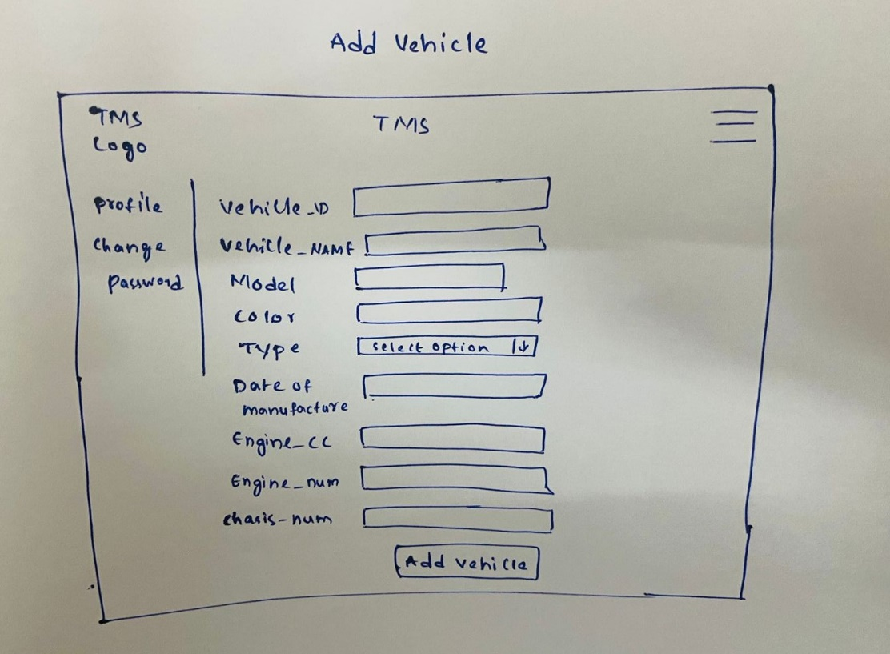

**ADD OFFENCE**

**TRANSEFR VEHICLE**

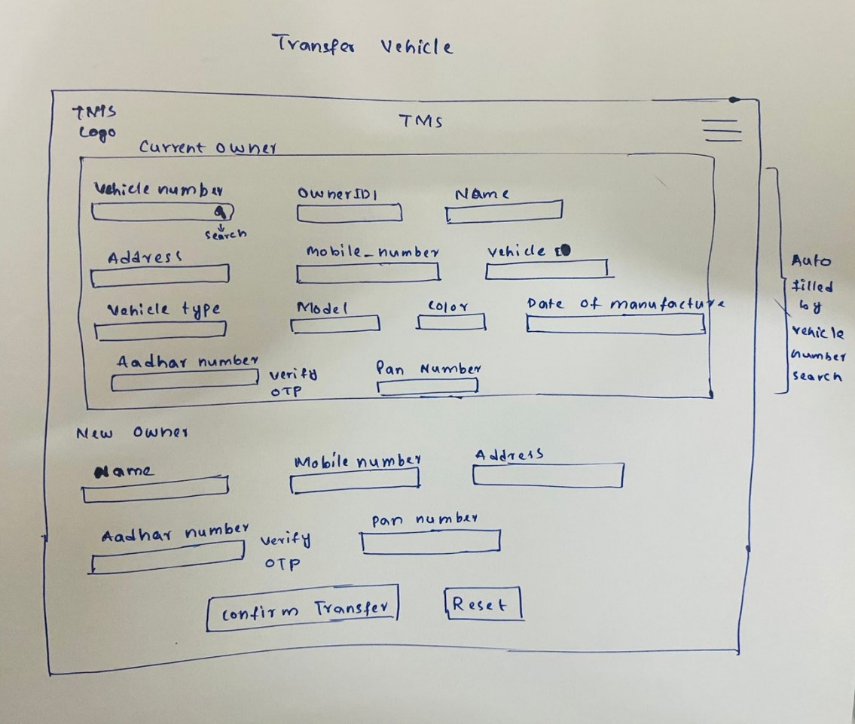

**COP**

**MODIFY OFFENCES**

**REPORT GENERATION**

